**CHAPTER 1**

**INTRODUCTION**

**1.1 AIM**

The scope of the project is to provide the users an amazing and interactive experience on marketing. By viewing advertisement through this application the user will get an experience equal to how they will get on seeing a product really. This application will take the traditional way of marketing to next level.

**1.2 PROBLEM STATEMENT**

There are some applications which arrived before has a similar purpose as like this but it is still in its developing stage and has some major defect and issues. The issues like the clarity and detailed depiction of the 3-D model and also the time lag for the detection of marker and the generation of the model. In the older applications when the unique marker is detected it took more time for the 3-D model generation process. To overcome such issues and drawbacks this application VMARK is developed for patch up the flaws remained in the existing system and to take the traditional way of marketing to the next level.This application works on the basic notion that it generates a 3d model of a specific product when its corresponding marker is scanned and detected. This marker is technically known as the target-marker which will be unique that is totally different from one another. . At once when a marker gets detected it make a quick match with all the available markers in the database. When it finally recognizes the correct marker the model stored for the corresponding marker will be retrieved from the database. Then the retrieved 3-D model will be generated and displayed on the application inreal-time

**1.3 DESCRIPTION**

**VMARK (VIRTUAL MARKETING)**

This application VMARK (virtual marketing) uses the concept of AUGMENTED REALITY which is a new emerging and advanced concept in computer world. The concept of augmented reality provides the users an amazing visual experience by integrating VIRTUAL OBJECTS with REAL ENTITIES. This application provides the user an interactive and amazing experience in marketing and it takes the field of marketing to its next level.

**SCANNING AND DETECTION OF MARKER**

This application works on the basic notion that it generates a 3-D model of a specific product when its corresponding marker is scanned and detected. This marker is technically known as the target-marker which will be unique that is totally different from one another.

**RETRIEVAL OF 3-D MODEL FROM DATABASE**

At once when a marker gets detected it makes a quick match with all the available markers in the database. When it finally recognizes the correct marker the model stored for the corresponding marker will be retrieved from the database.

**GENERATION AND DISPLAY OF 3-D MODEL**

When the application recognizes the valid marker the model stored for the corresponding marker will be retrieved from the database. Then the retrieved 3-D model will be generated and displayed on the application in real-time. The generated model will get positioned with reference to the world co-ordinates of the target marker.

**1.4 BENEFITS**

* Interactive application
* 3-D perspective of products
* Real-time processing
* 360 view of the product
* Easy to use

**1.5 OTHER APPLICATIONS**

* Virtual Marketing
* Educational purpose
* Concept model visualisation
* Information display

**CHAPTER 2**

**LITERATURE SURVEY**

**2.1 EXISTING SYSTEM**

Lots of applications which arrived before had a similar purpose as like this but it is still in its developing stage and has some major defect and issues. The issues like the clarity and detailed depiction of the 3-D model and also the time lag for the detection of marker and the generation of the model. In the older applications when the unique marker is detected it took more time for the 3-D concept of AGUMENTED REALITY is developed. Some of the major disadvantages and issues faced by the earlier applications are furnished as follows.

**2.1.1 DRAWBACKS OF EXISTING SYSTEM**

* There was always a consistent time lag between marker detection and model generation.
* There were insufficient clarity and detailed view 3d model used in existing systems.
* There were no integration between application and database.
* The applications were only made model specific.

**2.2 PROPOSED SYSTEM**

**2.2.1 VIRTUAL MARKETING SYSTEM (V-MARK)**

To overcome such issues and drawbacks this application VMARK is developed for patch up the flaws remained in the existing system and to take the traditional way of marketing to the next level.This application works onthe basic notion that it generates a 3d model of a specific product when its corresponding marker is scanned and detected. This marker is technically known as the target-marker which will be unique that is totally different from one another. At once when a marker gets detected it make a quick match with all the available markers in the database. When it finally recognizes the correct marker the model stored for the corresponding marker will be retrieved from the database. Then the retrieved 3-D model will be generated and displayed on the application in real-time.

**CHAPTER 3**

**SYSTEM ANALYSIS**

**3.1 FEASIBILITY STUDY**

The main objective of feasibility study is to test the Technical, operational and economical for adding new modules and debugging old running system. All system is feasible for adding new modules and debugging old running system.

There are aspects in the feasibility study portion of the preliminary investigation:

* Technical feasibility
* Economic feasibility
* Operational feasibility

**3.1.1 TECHNICAL FEASIBILITY**

This study is carried out to check the technical feasibility, that is, the technical requirements of the system. The only technical requirement needed for this project is Android. The requirements here are very modest because the system here supports very basic android version which is 2.4 and above.So, this system is technically feasible because it needs only android with a basic version.

**3.1.2 ECONOMIC FEASIBILITY**

Economic feasibility is the most frequently used method for evaluating the effectiveness of the proposed system. More commonly known as cost-benefit analysis, the procedure that costs for a proposed system and weights them against the tangible and intangible benefits of the system.Thesystem is cost effective because it is freely available as android application and can be downloaded at free of cost from the internet. The system is economically feasible because the users can freely download and install the app on their phones and can run it.

Needs Analysis

Initial Screening

Market and Demand Analysis

Technical Analysis

Alternative project

Financial and Economic Analysis

analysis project

change required

Impact Assessment

Fig. 3.1 Feasibility Analysis

**3.1.3 OPERATIONAL FEASIBILITY**

The aspect of the study is to check the level of acceptance of the system by the user. This includes the process of training the user to use the system efficiently. This system will not threaten the user instead it is friendly in its operation. All the user needs to have is an Internet connection provided to his mobile. The system is operationally feasible because the user can run the application just by starting the application and the application automatically activates the camera and it starts its operation.

**3.2 HARDWARE USED**

RAM : 1GB and above

Processor : Intel Processor

**3.3 SOFTWARE USED**

3-D modelling : 3ds max, Google sketch up

A-R Functionalities : UNITY integrated with VUFORIA

Development Environment : Eclipse

Operating System : Android OS (Jelly Beans)

Version : 2.4 and above

Frame Work : JDK 1.6

**CHAPTER 4**

**DETAILED DESIGN**

**4.1 SYSTEM ARCHITECTURE**

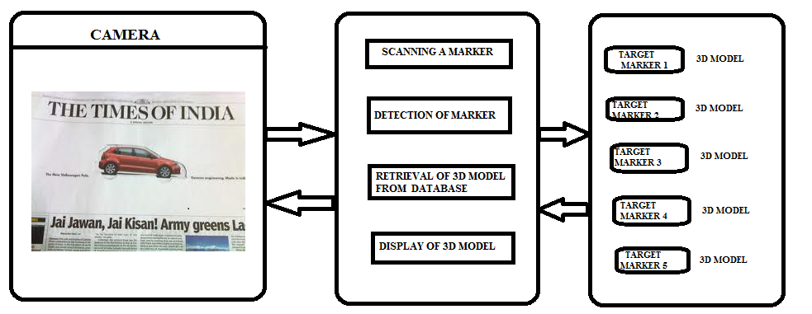

**Fig.4.1 System Architecture**

The above figure represents the typical architecture of the application VMARK (virtual marketing) using augmented reality.

**4.1.1 MODULES**

**1. Scanning of MARKER**

The input for this application is given in the form of a marker which is technically known as TARGET MARKER. This marker is unique.

**2. Marker Detection**

This unique marker is detected by our application which is scanned by our camera. The camera gets activated at once the application is started.

**3. Locating marker in database**

At once when the target marker is detected by the application’s camera, the marker will be taken as a key to match the same marker in the database. The database of this application is fully loaded with more number of markers with its corresponding 3D model.

**4. Retrieval of 3D model**

After locating the correct marker in the database, the corresponding 3D model of the marker is retrieved from the database.

**5. Generation and display of 3D-model**

After the retrieval of the 3D model form the database it is displayed on the screen of the device. The 3D model is positioned with respect to the world co-ordinates of the target marker.

**4.2 FLOW DIAGRAM**

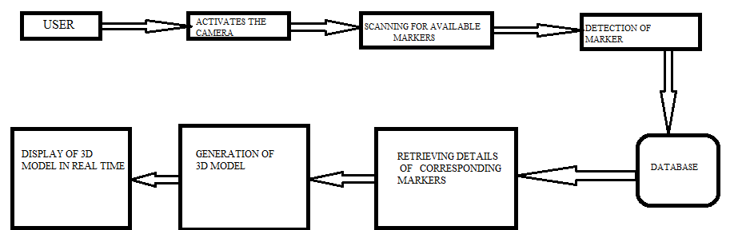**Fig 4.2 Flow Diagram**

The above flow diagram for the application VMARK (virtual marketing) using AUGMENTED REALITY represents the workflow of the application.

**4.3 UML DIAGRAMS**

The Unified Modelling Language (UML) is a general purpose modelling language in the field of software engineering. The basic level provides a set of graphic notation techniques to create visual methods of object-oriented software-intensive systems. Object-oriented analysis and design (OOAD) is a software engineering approach that models a system as a group of interacting objects.

**4.3.1 USE CASE DIAGRAM**

Use case describe the interaction between one or more actors and the system itself, represented as a sequence of simple steps that take part in a sequence of activities in a dialog with the system to achieve goal.



**Fig 4.3: Use Case Diagram**

There are three actors who are user, application and database necessary to run the application. The various functions of these actors like storing, entering, updating and retrieving the details are represented through use cases.

**4.3.2 SEQUENCE DIAGRAM**

A Sequence diagram shows, as parallel vertical lines different processes or objects that live simultaneously, and, as horizontal arrows, the messages exchanged between them, in the order in which they occur. This allows the specification of simple runtime scenarios in a graphical manner.



**Fig.4.4 Sequence Diagram**

The actions such as entering the details, storing and so on are expressed in a sequential order through vertical lines. The exchange of data between the actors(user, system and database) are represented by a set of horizontal lines.

**4.3.3 ACTIVITY DIAGRAM**

Activity diagram are graphical representation of workflows of stepwise activities and actions with support for choice, iteration and concurrency. In the Unified Modelling Language, activity diagrams can be used to describe the business and operational step-by-step workflows of components in a system. An activity diagram shows the overall flow of control.



**Fig.4.5 Activity Diagram**

The set of activities that takes place among the actors is represented through activity diagram. It has a start and stop state which indicates the user to start and stop the activity respectively. The sequence of activities are represented through arrow marks.

**4.3.4 COLLABORATION DIAGRAM**

A Collaboration diagram is easily represented by modelling objects in a system and representing the association between the objects as links. The interaction between the objects is denoted by arrows. To identify the sequence of invocation of these objects, a number is placed next to each of arrows.



**Fig.4.6 Collaboration Diagram**

According to the sequence diagram drawn, an automatic collaboration diagram would be generated which again indicates the relationship among the actors.

**CHAPTER 5**

**IMPLEMENTATION AND TESTING**

**5.1 IMPLEMENTATION**

**MODULES**

There are some modules in the architecture of this application which plays a very significant role in the process. These modules vary in their functionality, the various modules used in this application is furnish with its functionalities as follows

**5.1.a Scanning of MARKER**

The input for this application is given in the form of a marker which is technically known as TARGET MARKER. This marker is unique.

**5.1.b Marker Detection**

This unique marker is detected by our application which is scanned by our camera. The camera gets activated at once the application is started.

**5.1.c Locating marker in database**

At once when the target marker is detected by the application’s camera, the marker will be taken as a key to match the same marker in the database. The database of this application is fully loaded with more number of markers with its corresponding 3D model.

**5.1.d Retrieval of 3D model**

After locating the correct marker in the database, the corresponding 3D model of the marker is retrieved from the database.

**5.1.e Generation and display of 3D-model**

After the retrieval of the 3D model form the database it is displayed on the screen of the device. The 3D model is positioned with respect to the world coordinates of the target marker.

**5.2 TESTING**

Testing is an important phase that focuses on an empirical investigation in which the results describe the quality of the system. It cannot confirm system functions properly under all conditions but can establish that it fails under specific conditions. The prime purpose of testing is to guarantee that system successfully built and tested in the development phase meets all the requirements and design parameters.

TEST PLANNING

TEST ANALYSIS

TEST CASE IDENTIFICATION

TEST EXECUTION

FINAL TESTING

IMPLEMENTA-TION

**Fig.5.1 Process of Testing**

**5.2.1 UNIT TESTING**

**MARKER DETECTION**

Table 5.1 Marker detection

|  |  |  |  |  |
| --- | --- | --- | --- | --- |
| No | Test Case | Expected Output | Observed Output | Result |
| 1 | Scan the unique target marker with the application | Generate and display the corresponding 3-D model of the scanned marker | The 3-D model ofthe corresponding target marker is displayed | Pass |
| 2 | Scan things other than the unique marker | Should not respond to the marker which is not true | Does not respond | Pass |

**GENERATION AND DISPLAY OF 3-DMODEL**

Table 5.2 Generation and display of 3-dmodel

|  |  |  |  |  |
| --- | --- | --- | --- | --- |
| No | Test Case | Expected Output | Observed Output | Result |
| 1 | Scan the marker | Generation of valid3-D model for its target marker | 3-D model for the respected marker is generated. | Pass |

**INTEGRATION TESTING**

Table 5.3 Integration Testing

|  |  |  |  |  |
| --- | --- | --- | --- | --- |
| No | Test Case | Expected Output | Observed Output | Result |
| 1 | Scan marker through application camera | Detect marker and display  3-D MODEL | Marker is detected and 3-D MODEL is displayed | Pass |

**5.2.3 FUNCTIONAL TESTING**

Table 5.4 Functional Testing

|  |  |  |  |  |
| --- | --- | --- | --- | --- |
| No | Test Case | Expected Output | Observed Output | Result |
| 1 | Input is given to application in the form of unique target marker | 3-D MODEL of the scanned marker should be generated. | 3-D MODEL of the scanned marker is generated | Pass |

5.2.4 ACCEPTANCE TESTING

Table 5.7 Acceptance Testing

|  |  |  |  |  |
| --- | --- | --- | --- | --- |
| No | Test Case | Expected Output | Observed Output | Result |
| 1 | Valid target marker is scanned | 3D MODEL should be generated and displayed | 3D MODEL is generated and displayed | Pass |
| 2 | Invalid target marker is scanned | 3D MODEL should not be generated and displayed | 3D MODEL is not generated and displayed | Pass |

**5.3 TEST PLAN**

The project is tested to verify its correctness and identify the bugs. The test plan includes the various test cases that acts as the set of conditions or variables that determine whether the corresponding feature in the system is working as it originally established to do so. When this test plan is executed, the errors spotted are rectified and the final testing yields following result.

**5.4 TEST ANALYSIS**

In this phase of testing, the requirements for software testing are analysed and later its feasibility is determined. In the feasibility study the possibility of project development is found through suitable test cases.

**5.5 RESULT**

The application is tested and found to function as expected with no errors. This application provides an interface for the users to book the ticket in an efficient way. Thus the ticket is booked as per the user’s request using speech recognition.

**CHAPTER 6**

**CONCLUSION AND FUTURE ENHANCEMENT**

**6.1 CONCLUSION**

We believe that the virtual marketing application is an application which would take marketing world to its next level and give user a great interactive and new experience in viewing and purchasing of products. This gives user a feel as like they look the product which is there really in front of them.

**6.2 FUTURE ENHANCEMENT**

For now this application has been developed for specific product visualization. We are working towards a great enhancement like keeping database in a server and make the application generic to all, So that each and every company who wants to market their product in this amazing way can upload their 3D model of their product. Once they upload their model it will be assigned to an unique identification which will act as the target marker. Thus this application will get generalized and common.

**APPENDIX A**

**SAMPLE CODING**

**First Activity**

importandroid.os.Bundle;

importandroid.view.KeyEvent;

importandroid.view.View;

importandroid.view.Window;

importandroid.view.WindowManager;

publicclassUnityPlayerNativeActivityextendsNativeActivity

{

protectedUnityPlayermUnityPlayer; // don't change the name of this variable; referenced from native code

// UnityPlayer.init() should be called before attaching the view to a layout - it will load the native code.

// UnityPlayer.quit() should be the last thing called - it will unload the native code.

protectedvoidonCreate (Bundle savedInstanceState)

{

requestWindowFeature(Window.*FEATURE_NO_TITLE*);

super.onCreate(savedInstanceState);

getWindow().takeSurface(null);

setTheme(android.R.style.*Theme_NoTitleBar_Fullscreen*);

getWindow().setFormat(PixelFormat.*RGB_565*);

mUnityPlayer = newUnityPlayer(this);

if (mUnityPlayer.getSettings ().getBoolean ("hide_status_bar", true))

getWindow().setFlags (WindowManager.LayoutParams.*FLAG_FULLSCREEN*,

WindowManager.LayoutParams.*FLAG_FULLSCREEN*);

intglesMode = mUnityPlayer.getSettings().getInt("gles_mode", 1);

boolean trueColor8888 = false;

mUnityPlayer.init(glesMode, trueColor8888);

View playerView = mUnityPlayer.getView();

setContentView(playerView);

playerView.requestFocus();

}

protectedvoidonDestroy ()

{

mUnityPlayer.quit();

super.onDestroy();

}

// onPause()/onResume() must be sent to UnityPlayer to enable pause and resource recreation on resume.

protectedvoidonPause()

{

super.onPause();

mUnityPlayer.pause();

}

protectedvoidonResume()

{

super.onResume();

mUnityPlayer.resume();

}

publicvoidonConfigurationChanged(Configuration newConfig)

{

super.onConfigurationChanged(newConfig);

mUnityPlayer.configurationChanged(newConfig);

}

publicvoidonWindowFocusChanged(booleanhasFocus)

{

super.onWindowFocusChanged(hasFocus);

mUnityPlayer.windowFocusChanged(hasFocus);

}

publicbooleandispatchKeyEvent(KeyEvent event)

{

if (event.getAction() == KeyEvent.*ACTION_MULTIPLE*)

returnmUnityPlayer.onKeyMultiple(event.getKeyCode(), event.getRepeatCount(), event);

returnsuper.dispatchKeyEvent(event);}

**APPENDIX-B**

**SCREEN SHOTS**

**WELCOME PAGE**

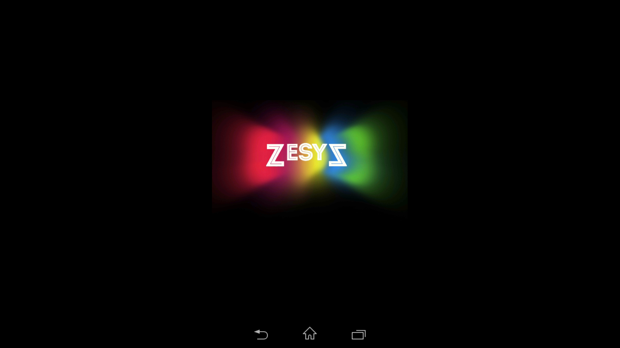

**Fig.b.1 Welcome Page**

When the user enters into the application, the first page that appears is the welcome page.This application works on the basic notion that it generates a 3d model of a specific product when its corresponding marker is scanned and detected. This marker is technically known as the target-marker which will be unique that is totally different from one another

**ADVERTISEMENT MARKER**

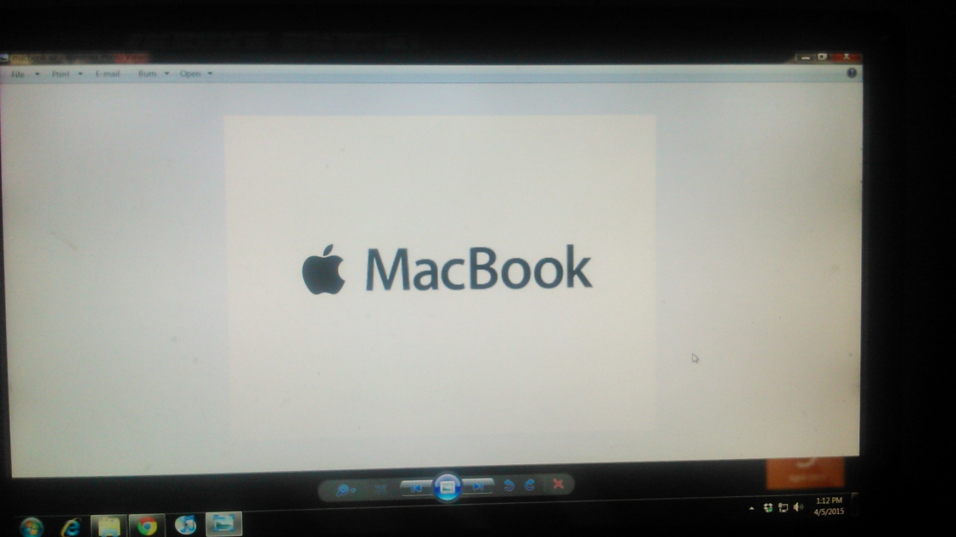

**Fig.b.2 ADVERTISEMENT MARKER**

When the user scans the above marker, say from an advertisement the 3Dmodel corresponding to this marker will be generated and displayed positioned with respect to the co-ordinates of this marker.This application works on the basic notion that it generates a 3d model of a specific product when its corresponding marker is scanned and detected. This marker is technically known as the target-marker which will be unique that is totally different from one another

**GENERATION AND DISPLAY OF 3D MODEL**

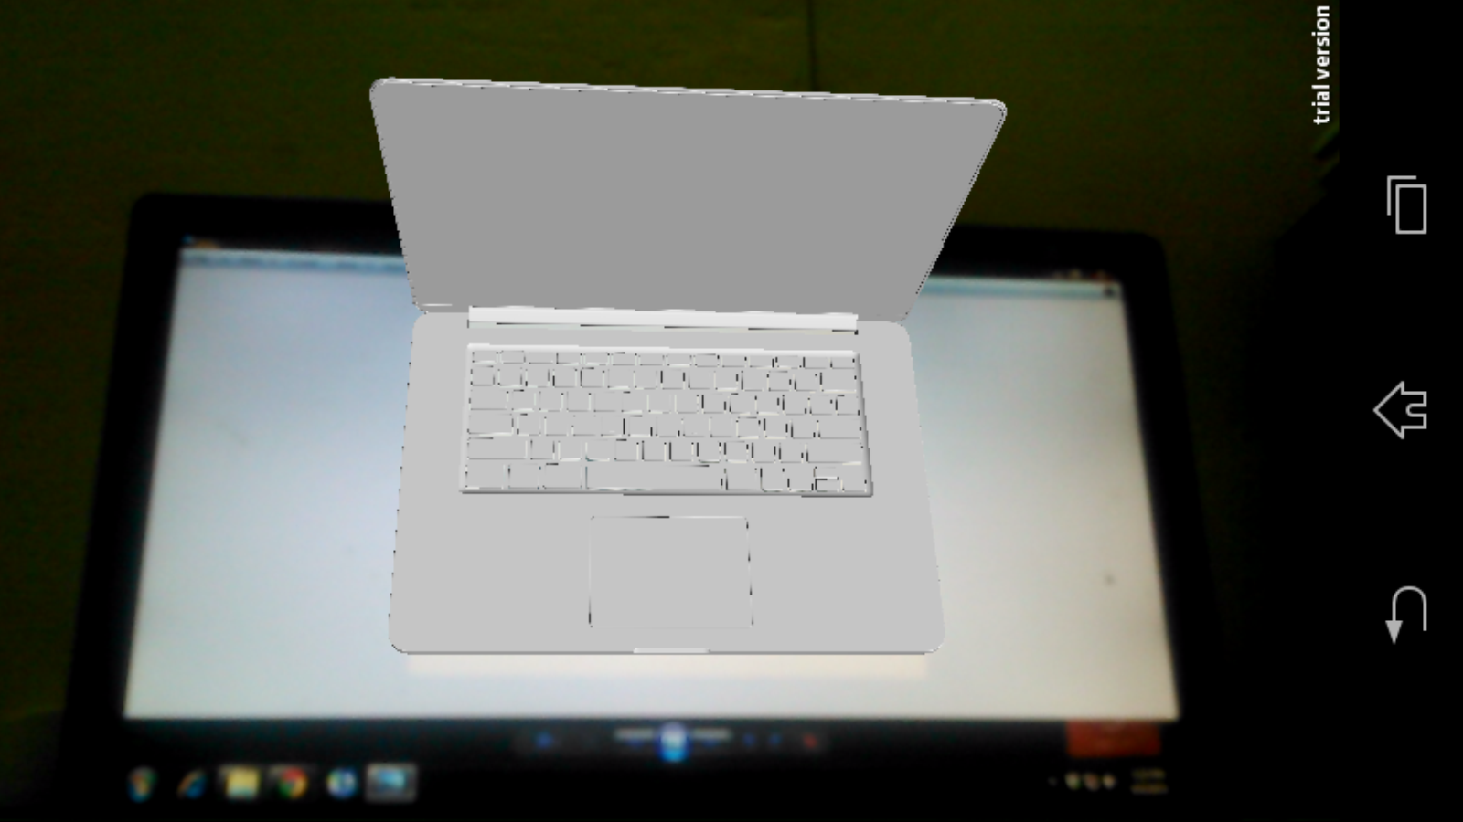

**Fig.b.3 GENERATION AND DISPLAY OF 3D MODEL**

When the user scans this marker and fed the application with this input the 3Dmodel corresponding to that marker is generated and displayed.This application uses the AR-concept for giving a new and more interactive experience in marketing. This application works on the basic notion that it generates a 3d model of a specific product when its corresponding marker is scanned and detected

**TOPVIEW**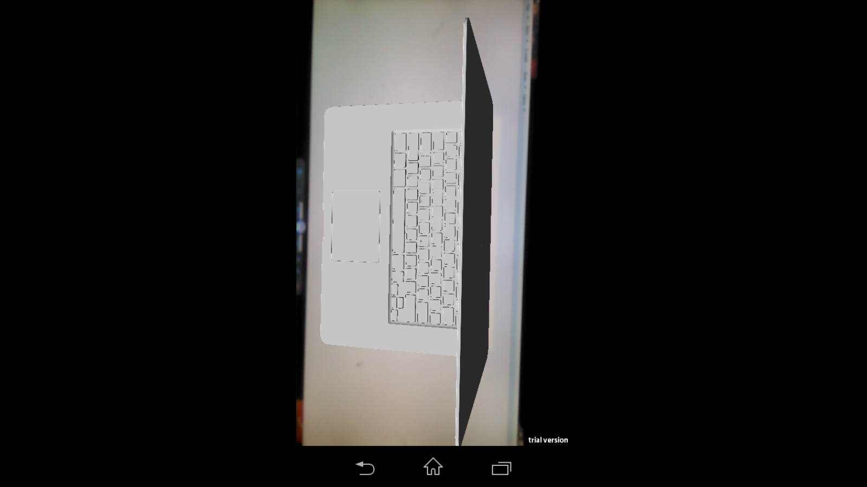

**Fig.b.4 TOP VIEW**

The user is able to view the product on their own perspective of the generated 3D model.. This marker is technically known as the target-marker which will be unique that is totally different from one another. Each and every model for its corresponding product will be assigned to a marker. These collections of marker and its model will be safely and comfortably stored in a database which is maintained in a server. When the user opens the application , camera gets activated and it scans for the available marker in its vision. At once when a marker gets detected it make a quick match with all the available markers in the database.

**SIDEVIEW**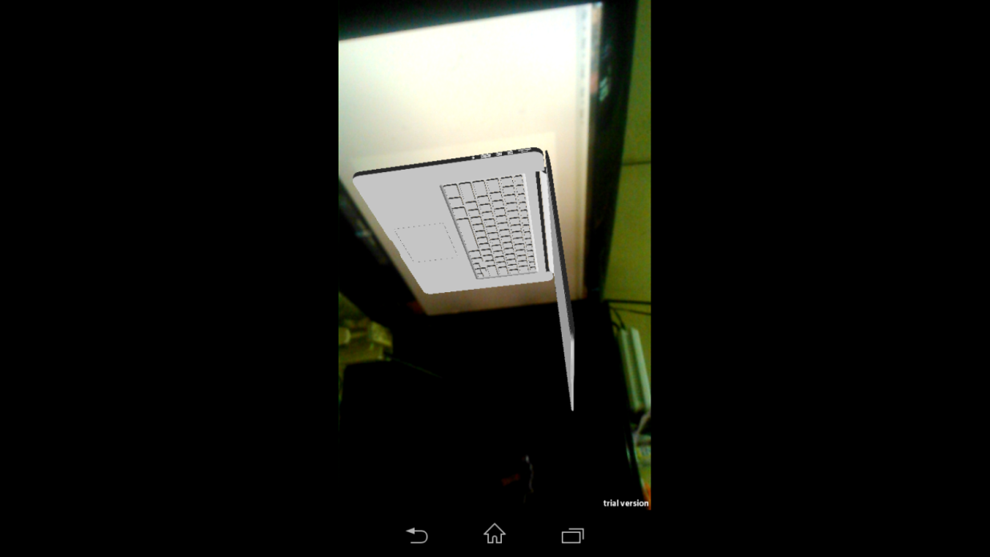

**Fig.b.5 SIDE VIEW**

**BACK VIEW**

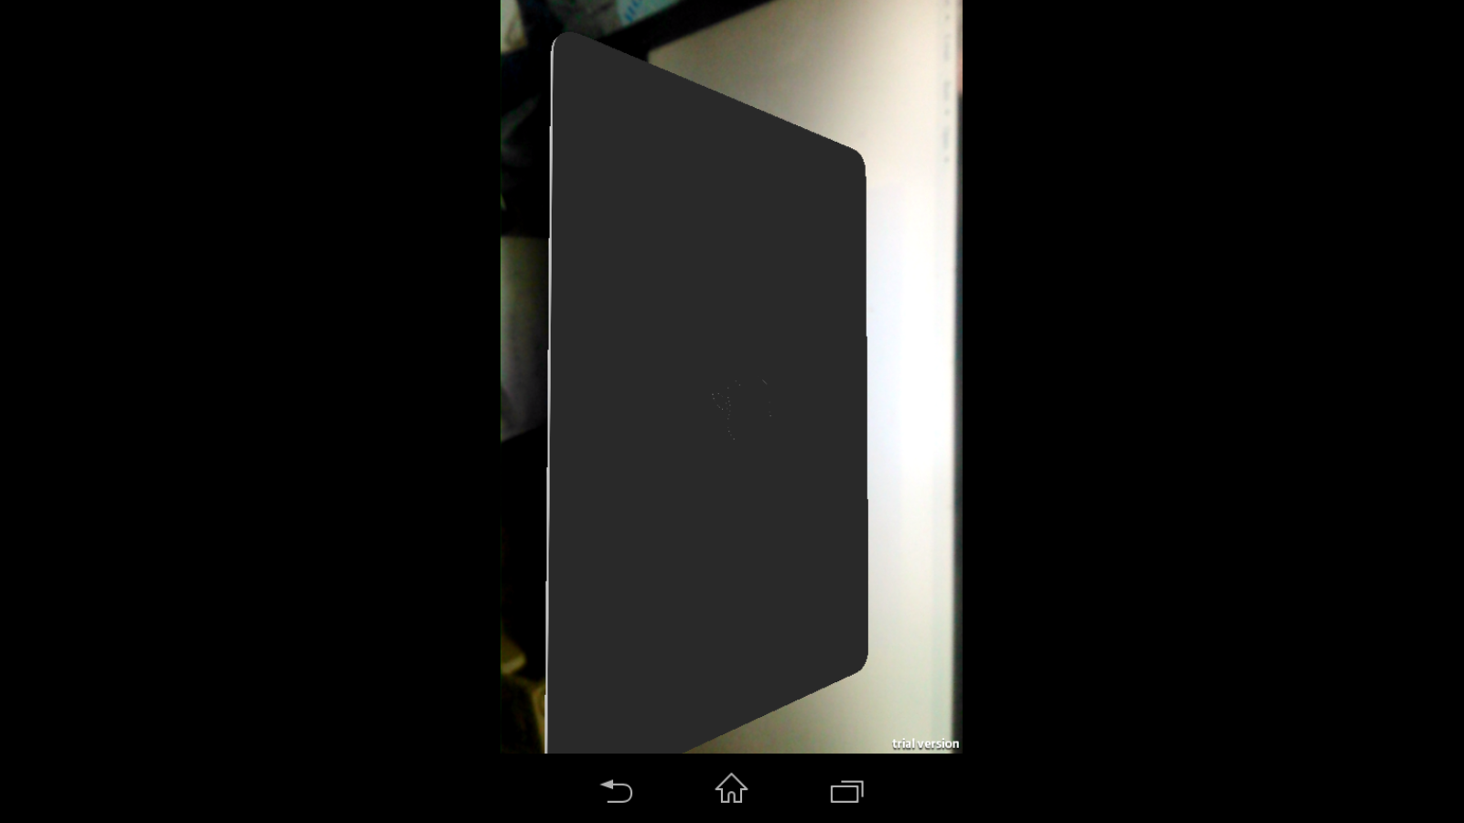

**Fig.b.6 BACK VIEW**

**CUSTOMVIEW**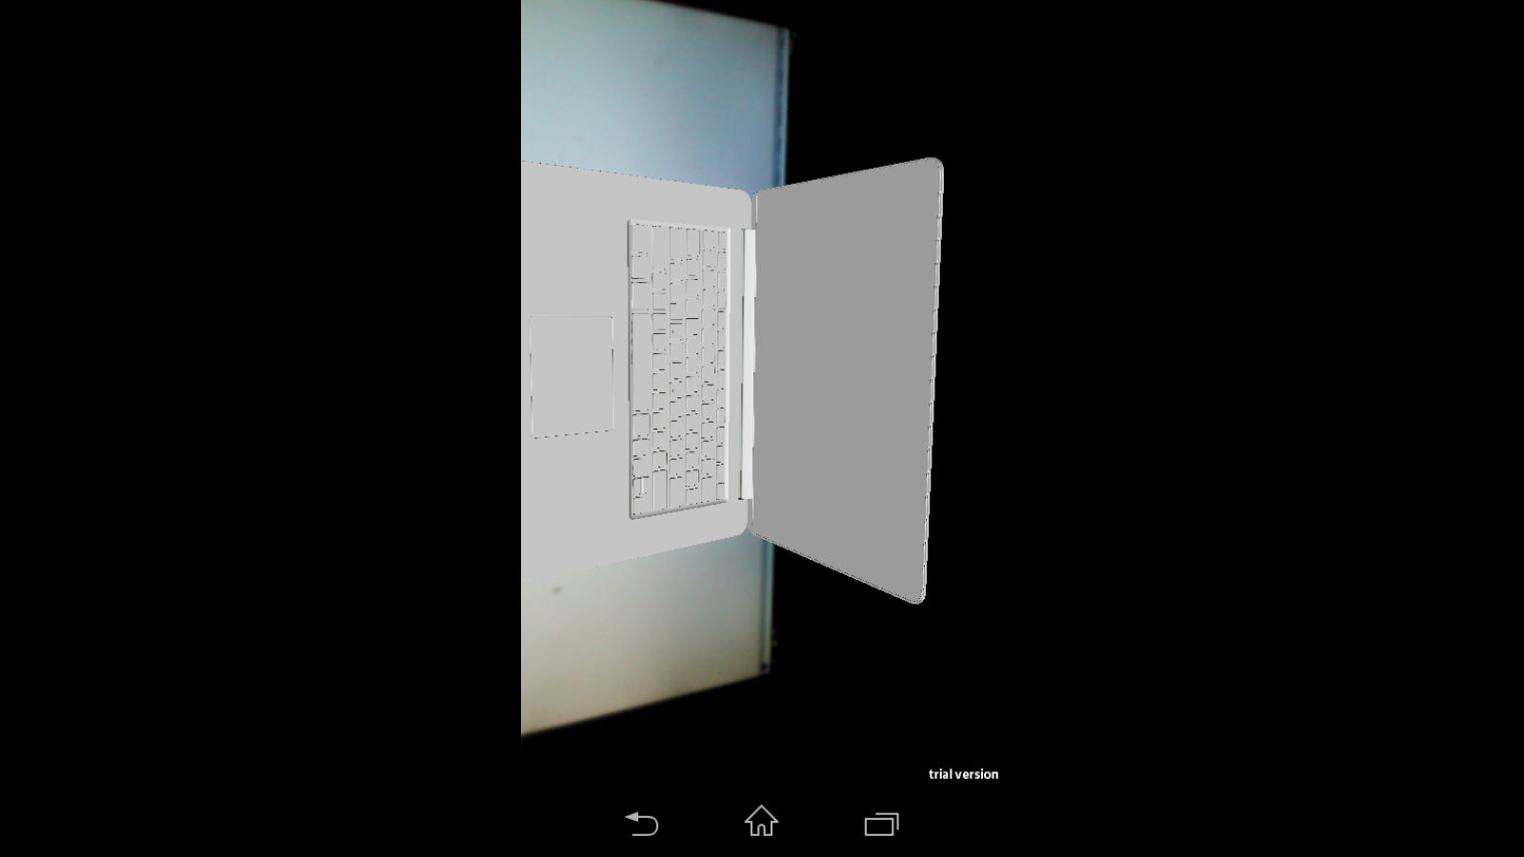

**Fig.b.7 CUSTOM VIEW**

**CLOSE VIEW**

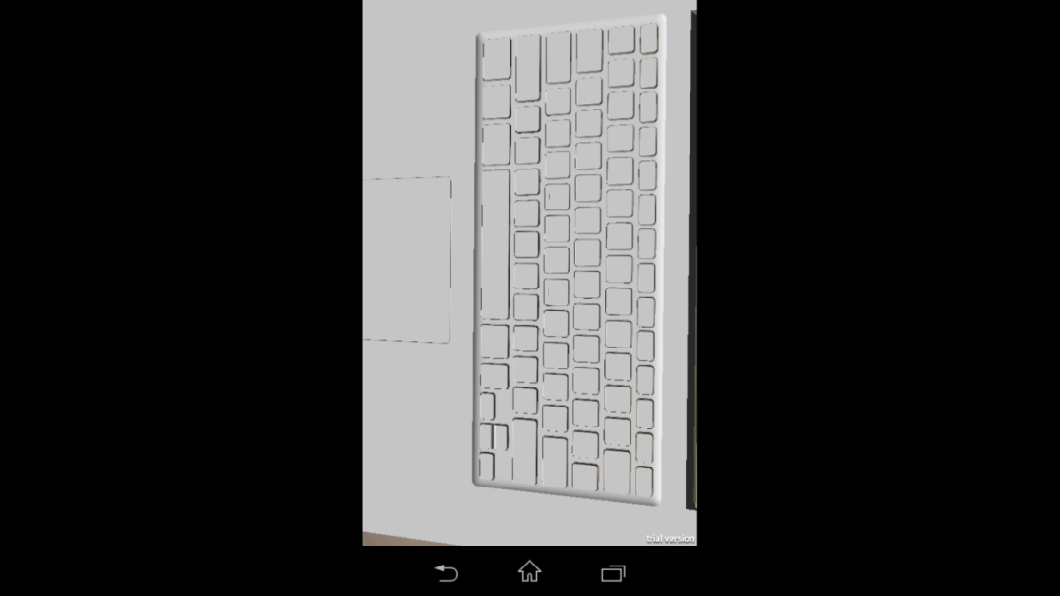

**Fig.b.8 CLOSE VIEW**

**ANY VIEW FOR OUR COMFORT**

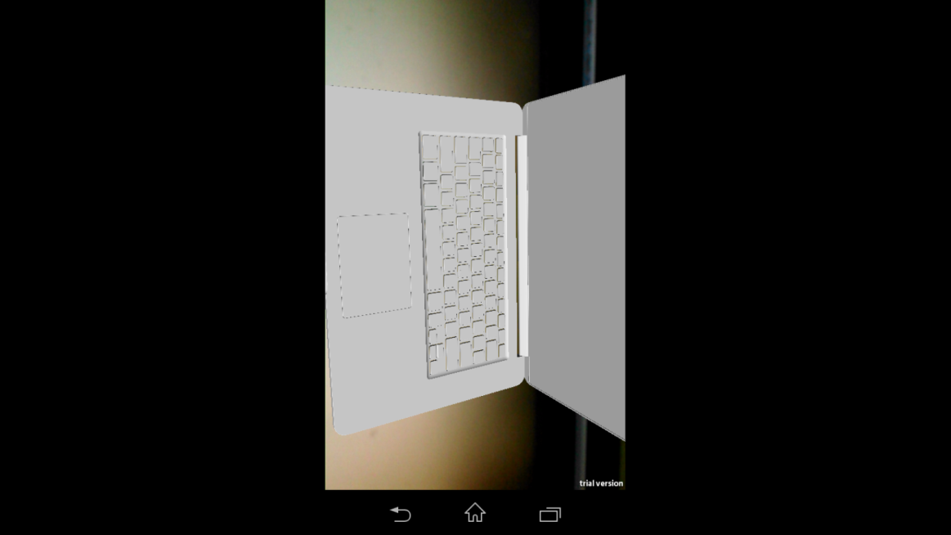

**Fig.b.9 ANY VIEW FOR OUR COMFORT**

**DETAILED MODELS**

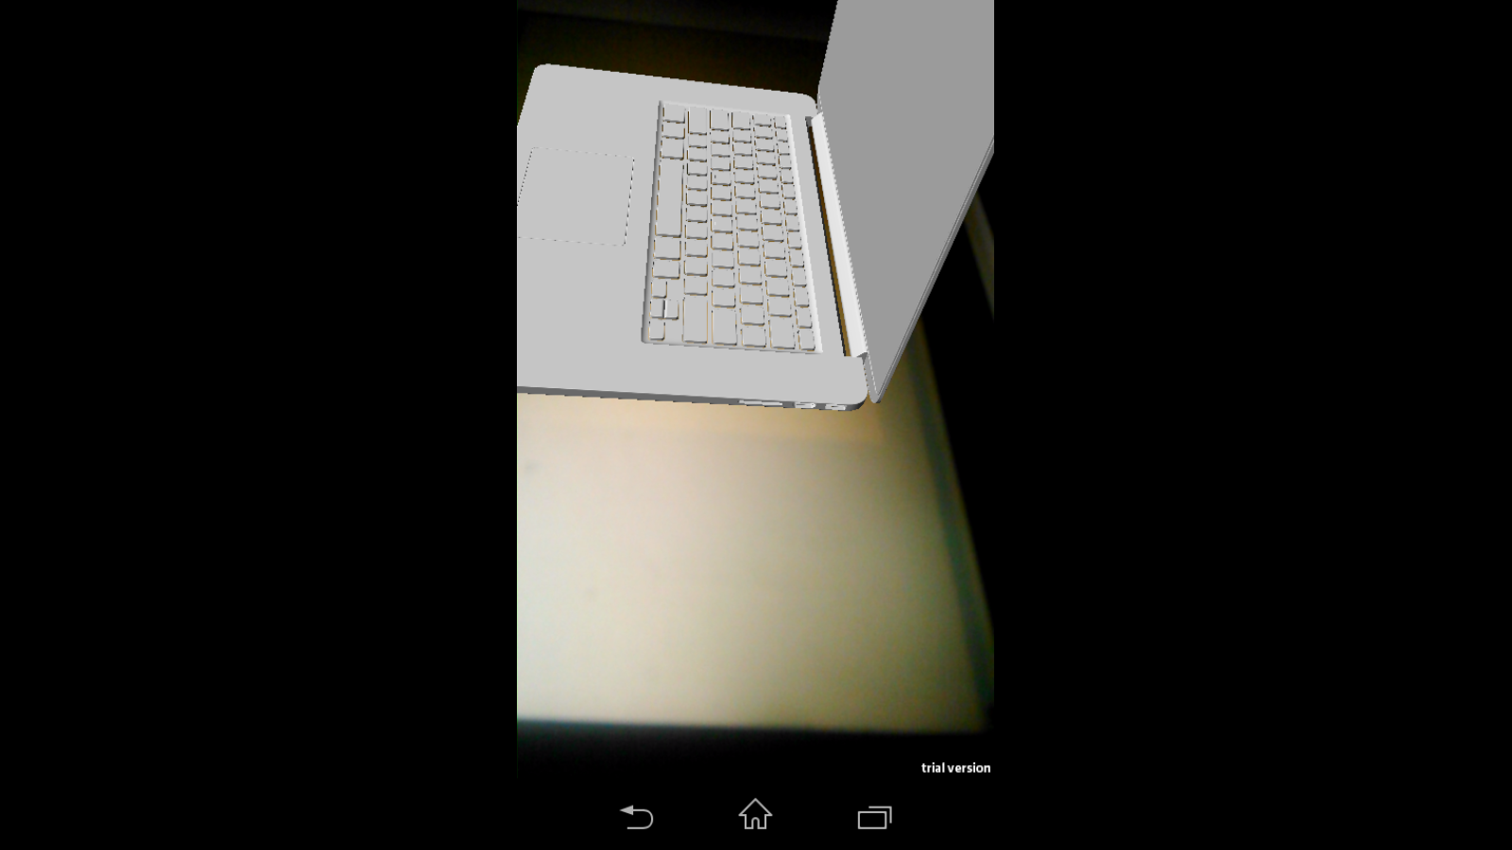

**Fig.b.10 DETAILED MODELS**

**EACH 3D MODEL GENRATED FOR MARKER**

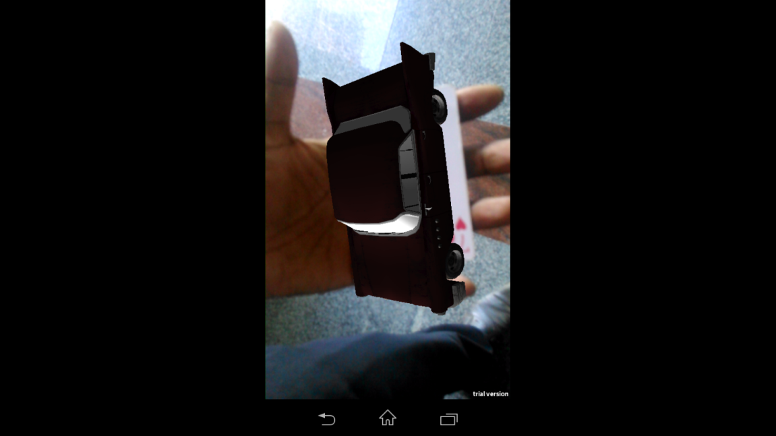

**Fig.b.11 Each 3D model is generated for its corresponding target marker**

APPLICATION DEVELOPMENT ENVIRONMENT

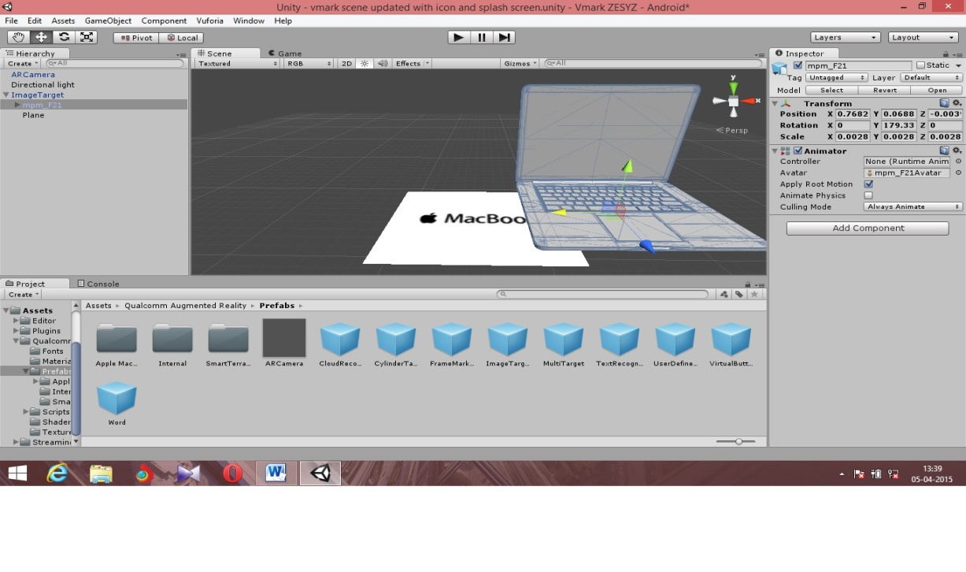 **Fig.b.12 APPLICATION DEVELOPMENT ENVIRONMENT**

**CREATION OF TARGET MARKER**

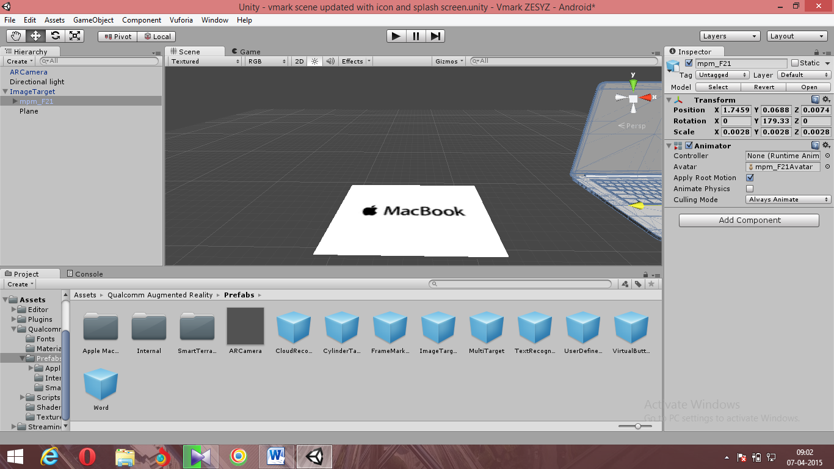

Fig.b.13 CREATION OF TARGET MARKER

**CREATION OF 3D MODEL**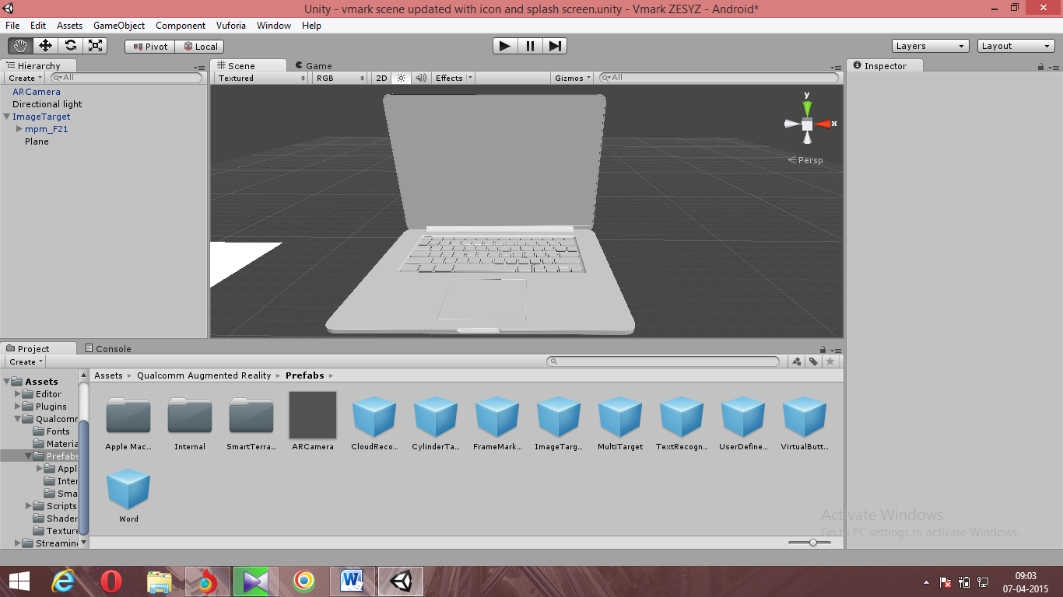

**Fig.b.14 CREATION OF 3D MODEL**

**POSITIONING OF 3DMODEL TO TARGET MARKER**

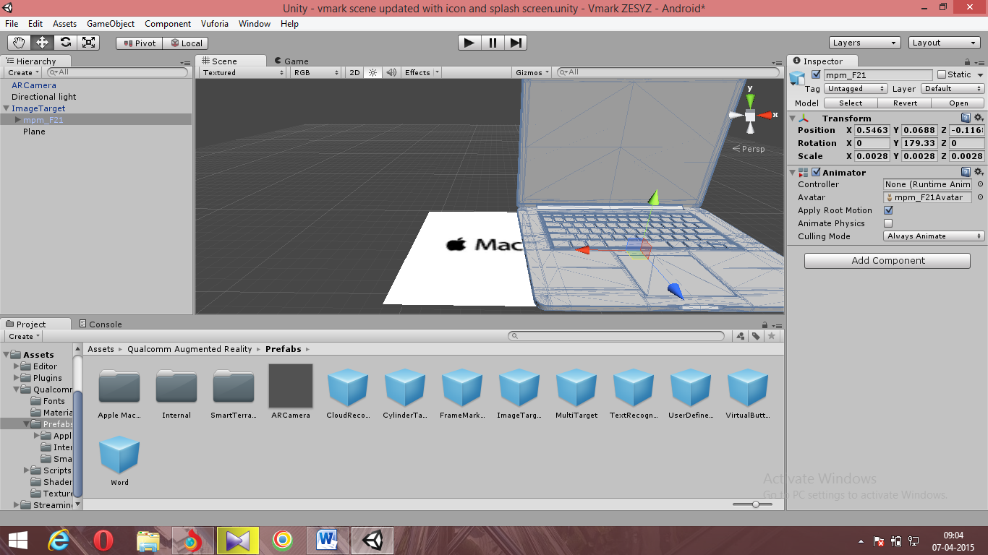

Fig.b.15 POSITIONING OF 3DMODEL TO TARGET MARKER

**INITIALIZATION OF AUGMENTED REALITY CAMERA**

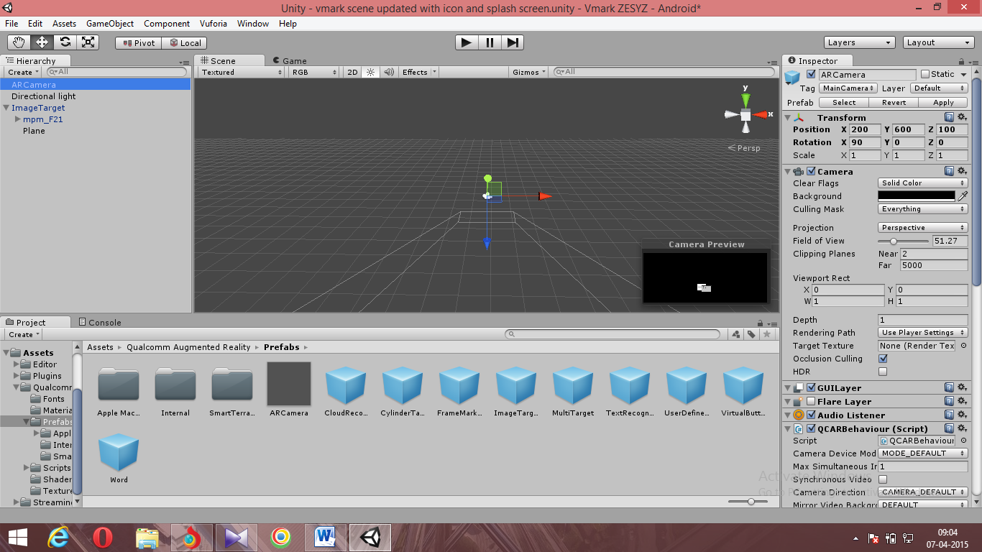

Fig.b.16 INITIALIZATION OF AUGMENTED REALITY CAMERA

**DIRECTIONAL LIGHT FOR MORE DETAIL**

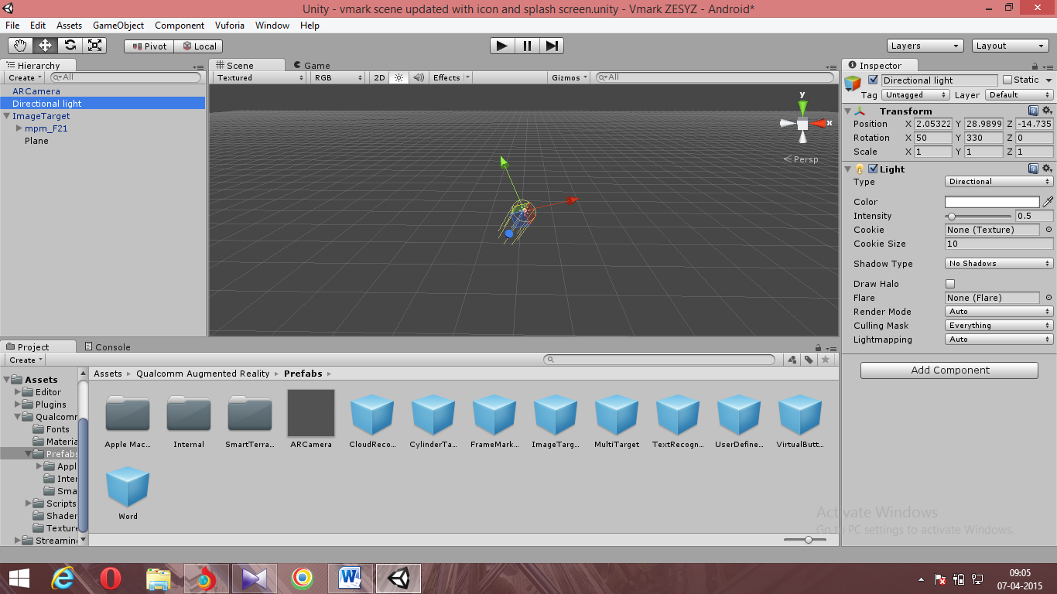

Fig.b.17 DIRECTIONAL LIGHT FOR MORE DETAIL

**MAPPING MODEL TO MARKER**

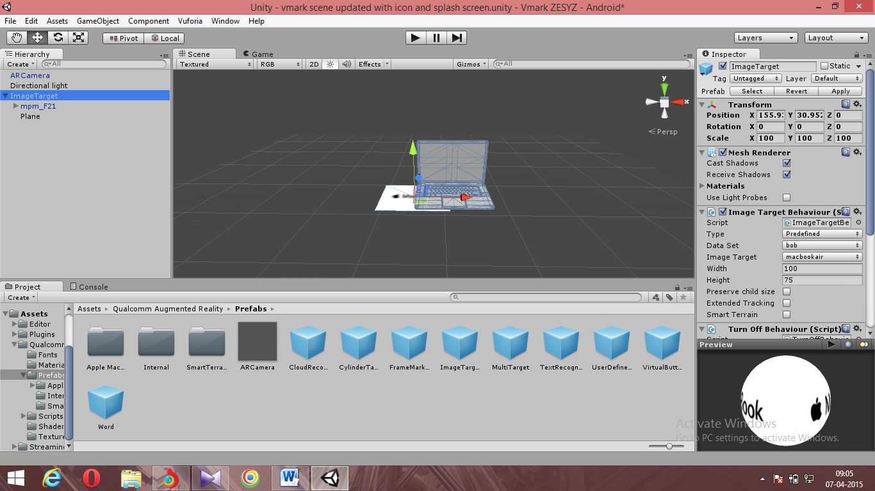

Fig.b.18 MAPPING MODEL TO MARKER

**VIRTUAL PLANE TO REDUCE UNSTABILITY**

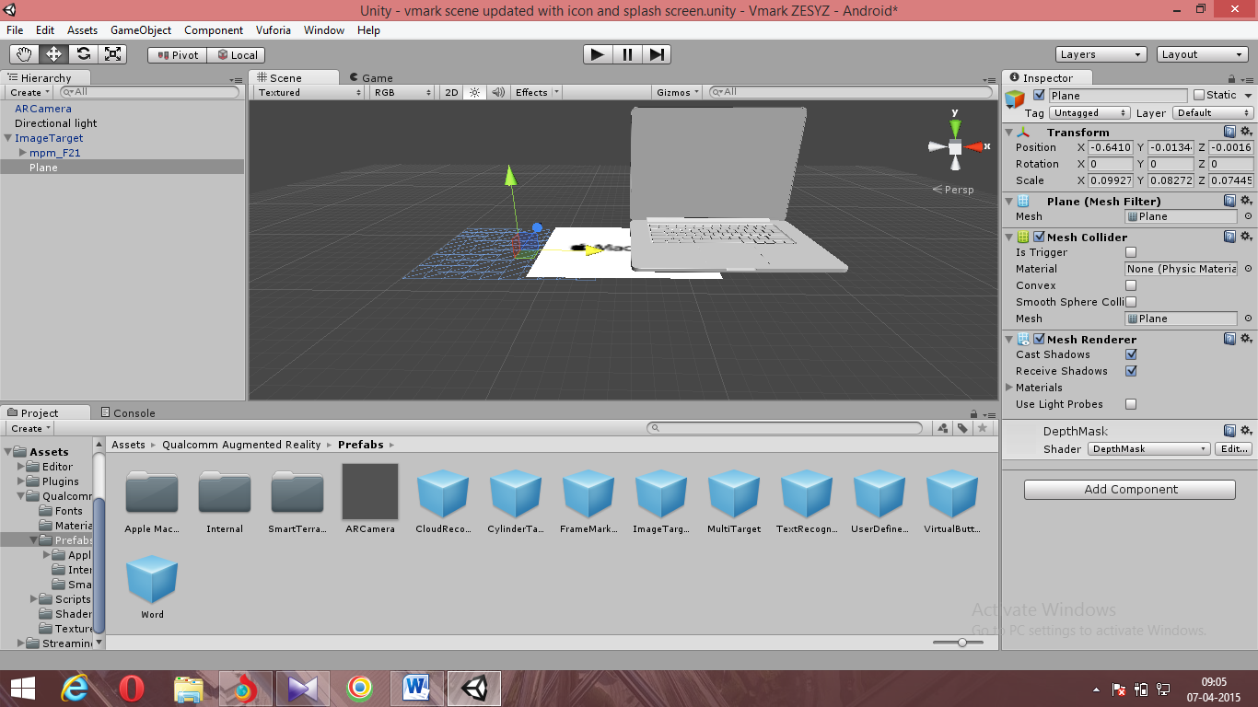

Fig.b.19 VIRTUAL PLANE TO REDUCE UNSTABILITY

**CUSTOMIZED BUILD SETTINGS**

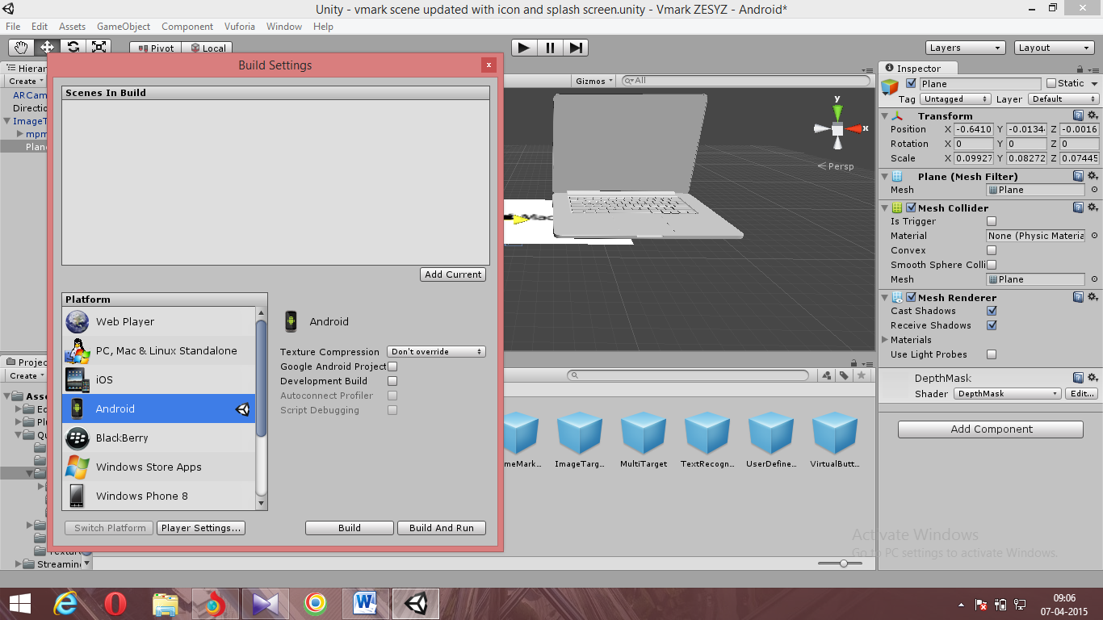

Fig.b.20 CUSTOMIZED BUILD SETTINGS

**PLAYER SETTINGS FOR APPLICATION**

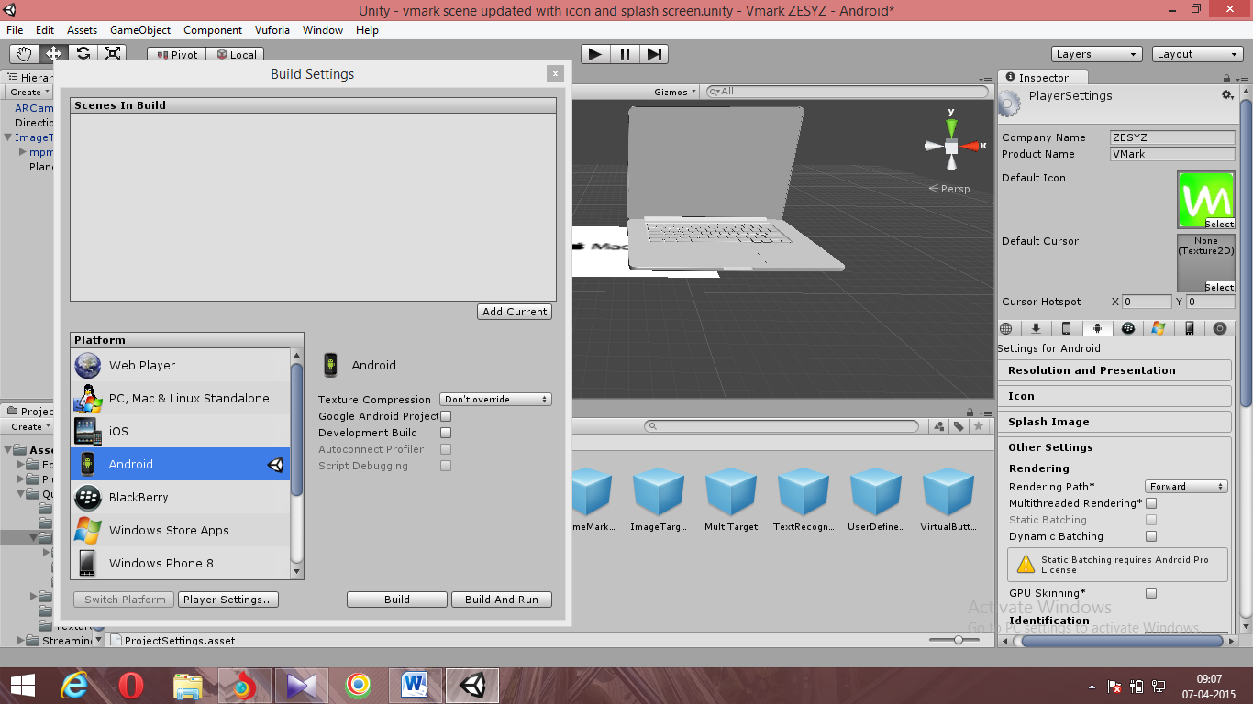

Fig.b.21 PLAYER SETTINGS FOR APPLICATION

**SCRIPTS COMPILATION**

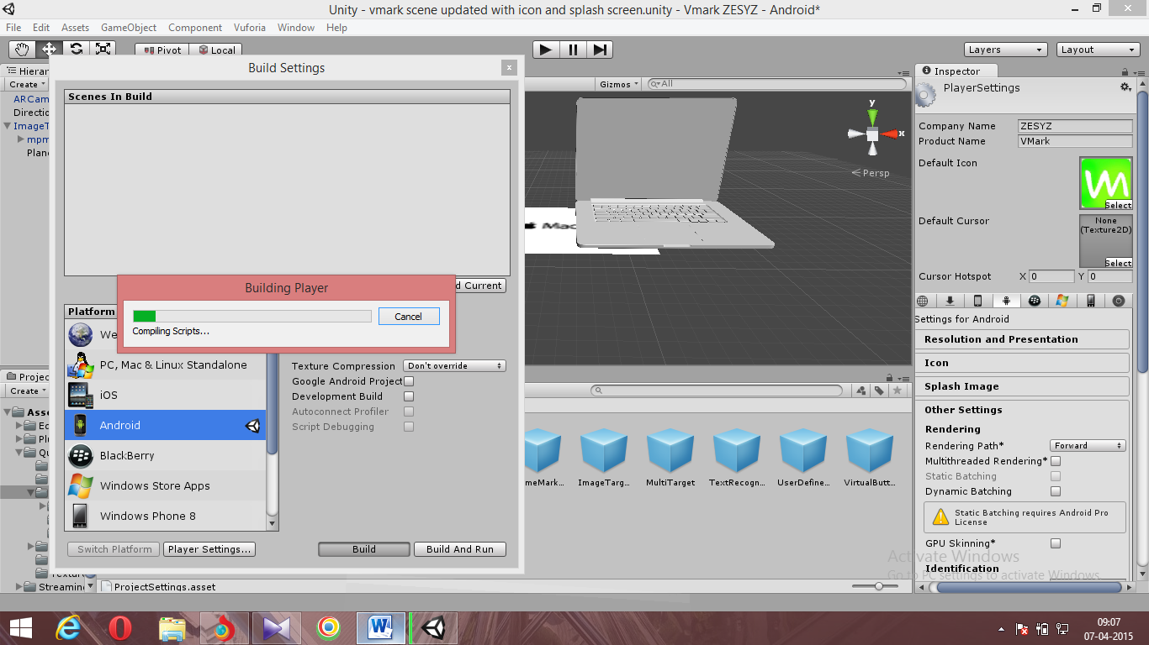

Fig.b.22 SCRIPTS COMPILATION

**PLAYER BUILD**

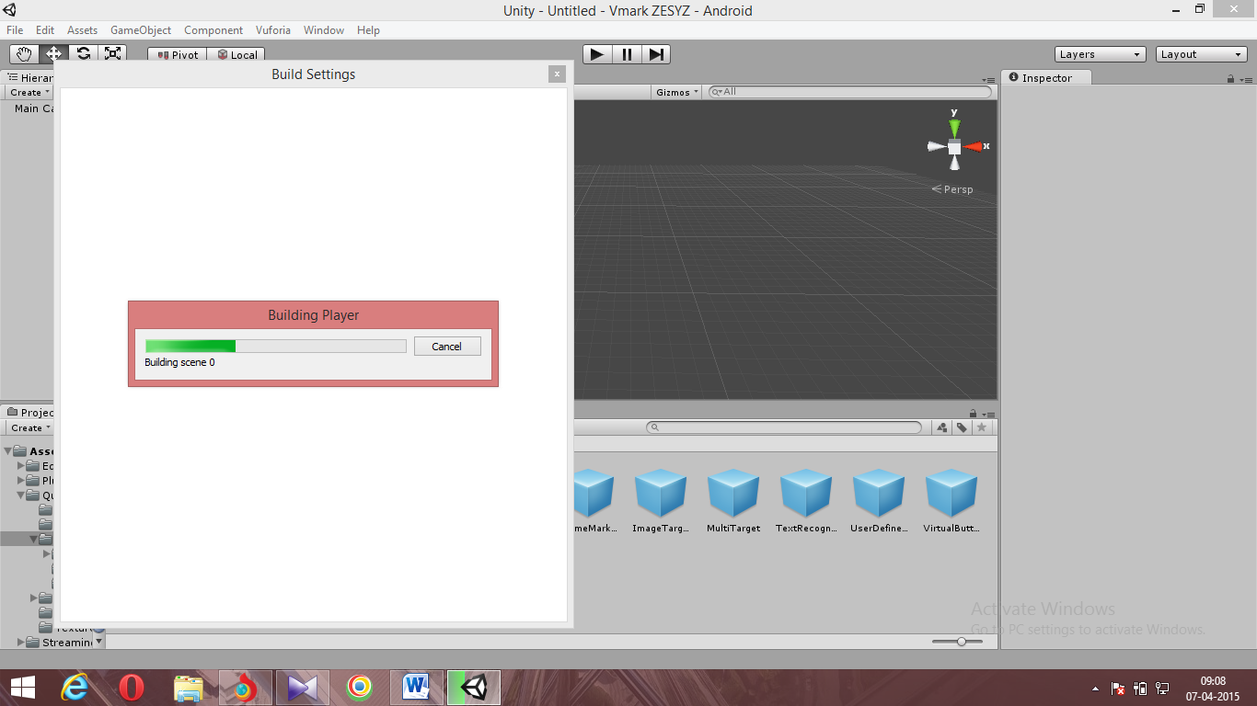

Fig.b.23 PLAYER BUILD

**BUILD FOR APPROPRIATE SDK VERSION**

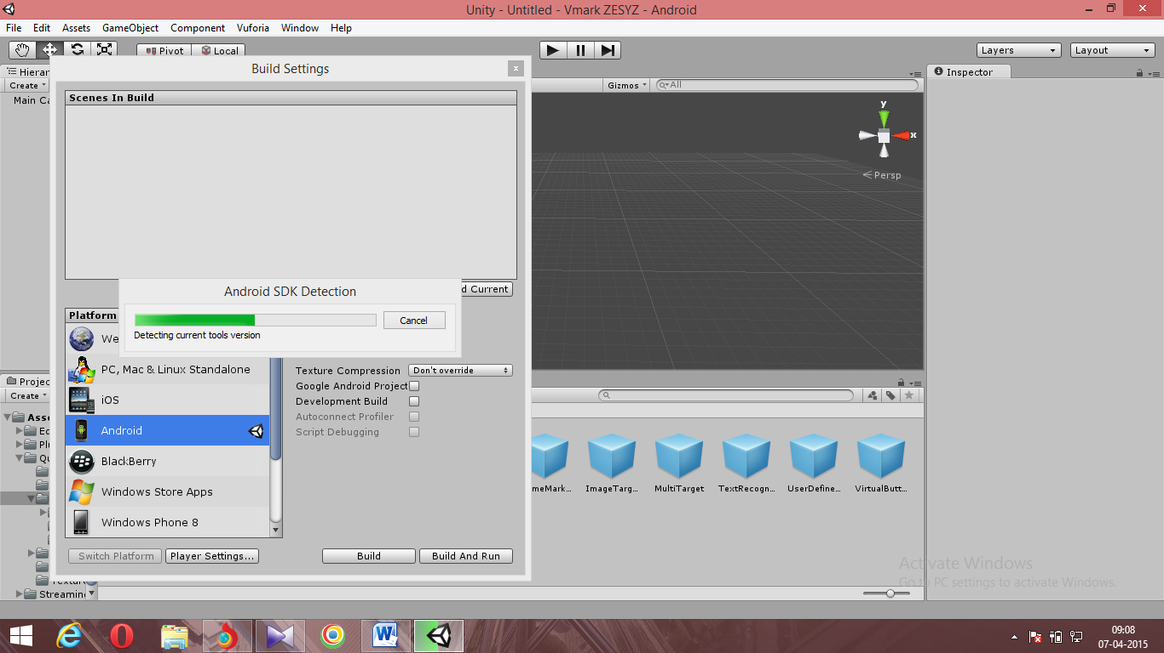

Fig.b.24 BUILD FOR APPROPRIATE SDK VERSION

**EXPORTING TO IDE AFTER BUILD**

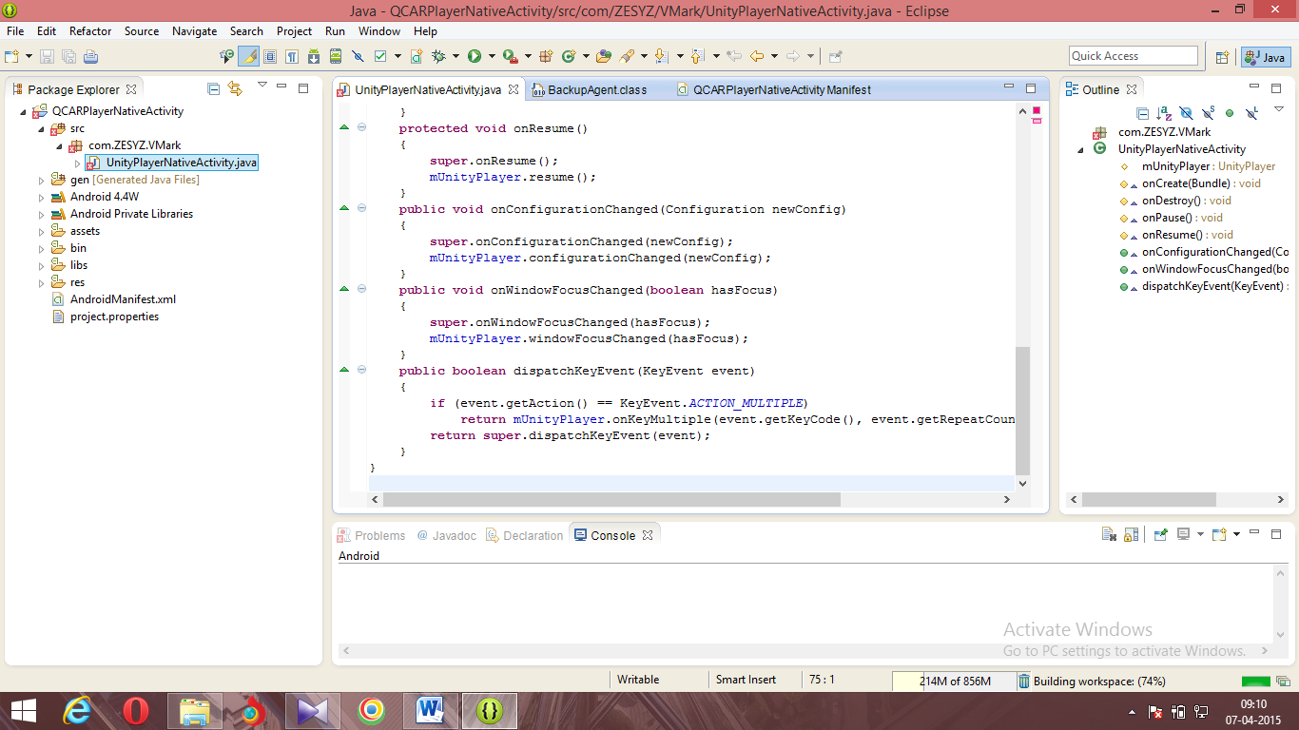

Fig.b.25 EXPORTING TO IDE AFTER BUILD

**AVD SETTINGS FOR APPLICATION**

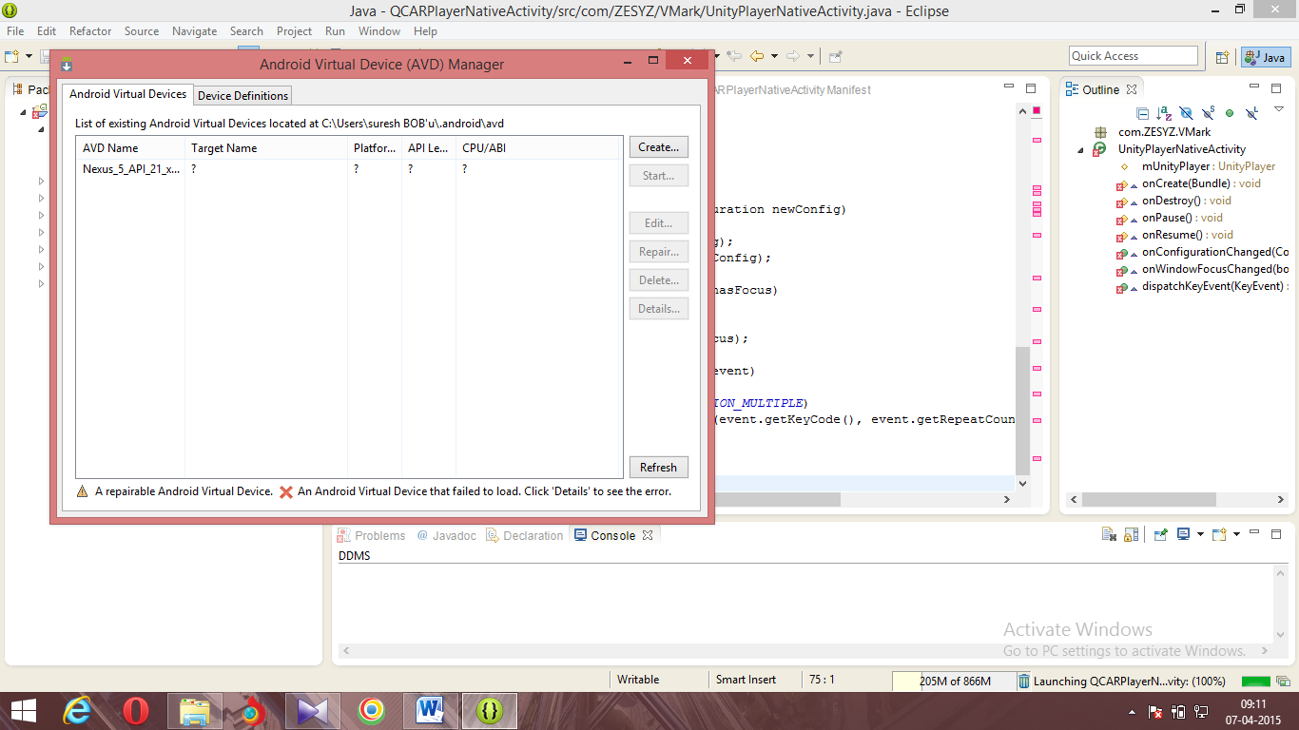

Fig.b.26 AVD SETTINGS FOR APPLICATION

**REFERENCES**

[1]UNDERSTANDING AUGMENTED REALITY CONCEPTS By Alan B. Craig.

[2]AUGMENTED REALITY CONCEPTS.

(https://www.lri.fr/~mackay/pdffiles/AVI98.AugmentedReality.pdf)

[3]RECENT ADVANCES IN AUGMENTED REALITY

(http://www.cc.gatech.edu/~blair/papers/ARsurveyCGA.pdf)

[4]Professional Android Application Development by *Reto Meier.*

Published by Wiley Publishing, Inc. Copyright © 2009 by Wiley Publishing,

Inc., Indianapolis, Indiana. Manufactured in the United States of America 10 9

8 7 6 5 4 3 2 1